**Probabilistic Models of Cognition**

**COGS566**

**2020/2021**

Name: Orçun Sami Tandoğan  
Number: 2535037

**Aim**

Our aim was how genes which are related to specific molecular pathways are changed in respect to weaning.

**Methods**:

Pymc3 tool has been used, widely, for probabiltisc result of gene expressions in manner of Bayes as Pymc3 provides tools for Bayesian inference.

**Results**

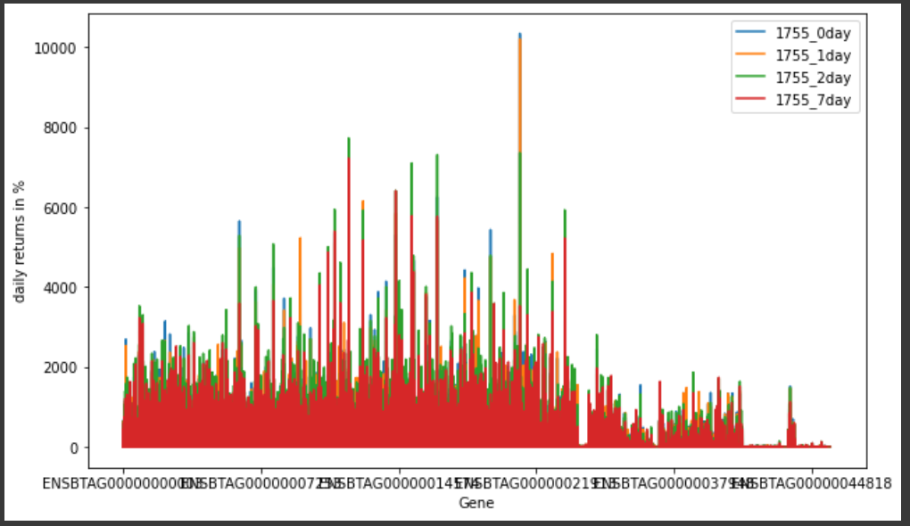

**Figure 1.0** Distribution of Gene Expressions of Control Group 1

We are trying to analyze gene expressions. Genes are in order and indexes are fixed. In Figure 1.0, it can be seen how gene expressions of one group.

There is also one of test groups expression exists in Figure 2.0. 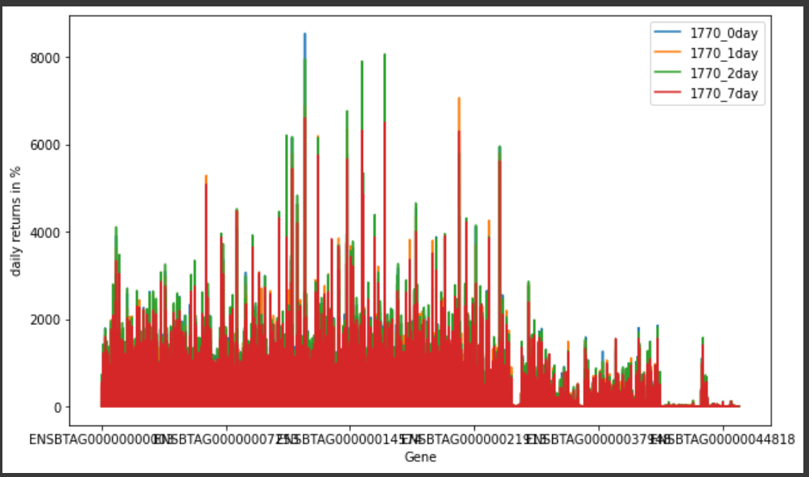  
**Figure 2.0** Distribution of Gene Expressions of Test Group 1

Distributions are tried to be redraw by mean and standard deviations upon first three day to guess last day. In this reason, Overall summary one control group`s values are assessed. It has been seen that there is high accuracy to guess, within group, Figure 3.0. 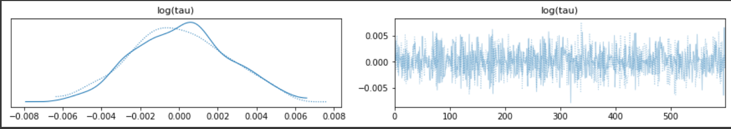  
**Figure 3.0** Summary Model Prediction of Tau Which Belongs To Control Group I Within Days

To have comparative analysis for between, the days, first model is created. Each group is divided, means are standard deviations are separated and differences of them, are stored in new variables. Posterior predictions are tried to be made.

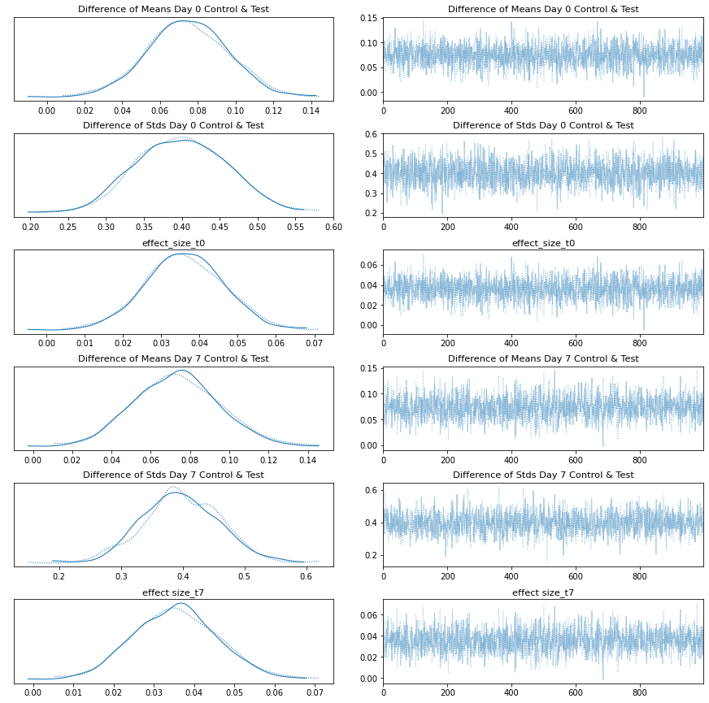

**Figure 4.0** Differences & Effects In Metropolis Method Day 0 & Day 7 Test & Control Groups

In Figure 4.0, differences of mean, std and effect size can be seen. Labels are better to be read like: Differences of Day 0 between control and test groups. Means, standard deviations and effect sizes are calculated. Days 0 and Day 7 control and test groups means and standard deviations can be found in Figure 5.0.

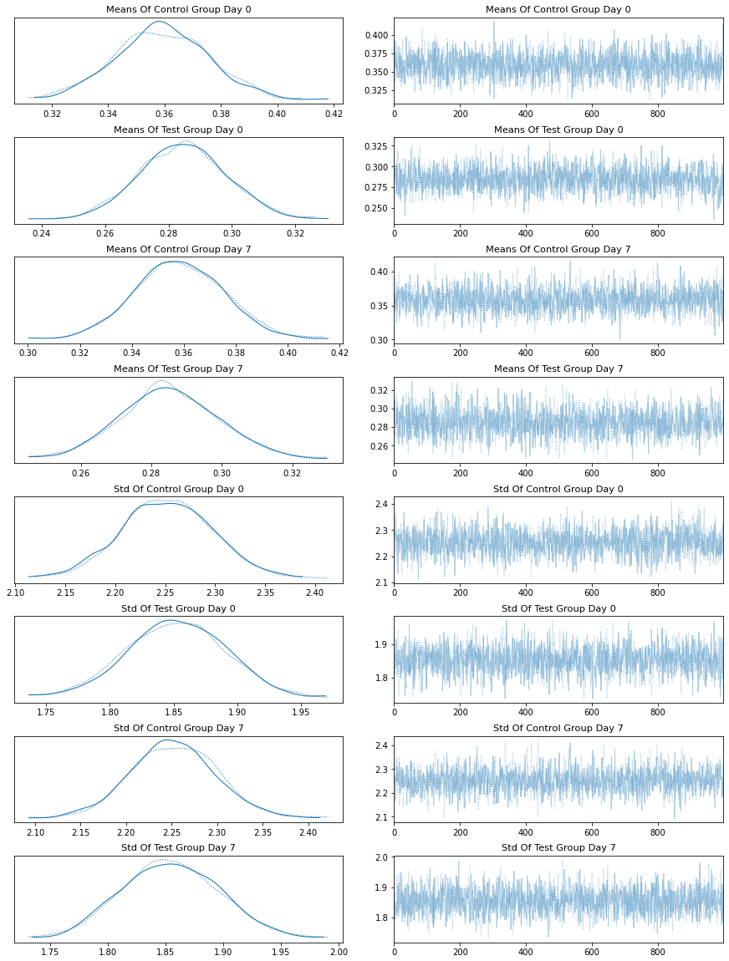

**Figure 5.0** In Comparative Analysis Of Day 0 & Day 7 Test & Control Groups

Additionally, there is also result of analyzing of Control Group I`s means, standard deviations, differences and effect sizes within days it has(Day 0 to Day 7). (Figure 6.0)

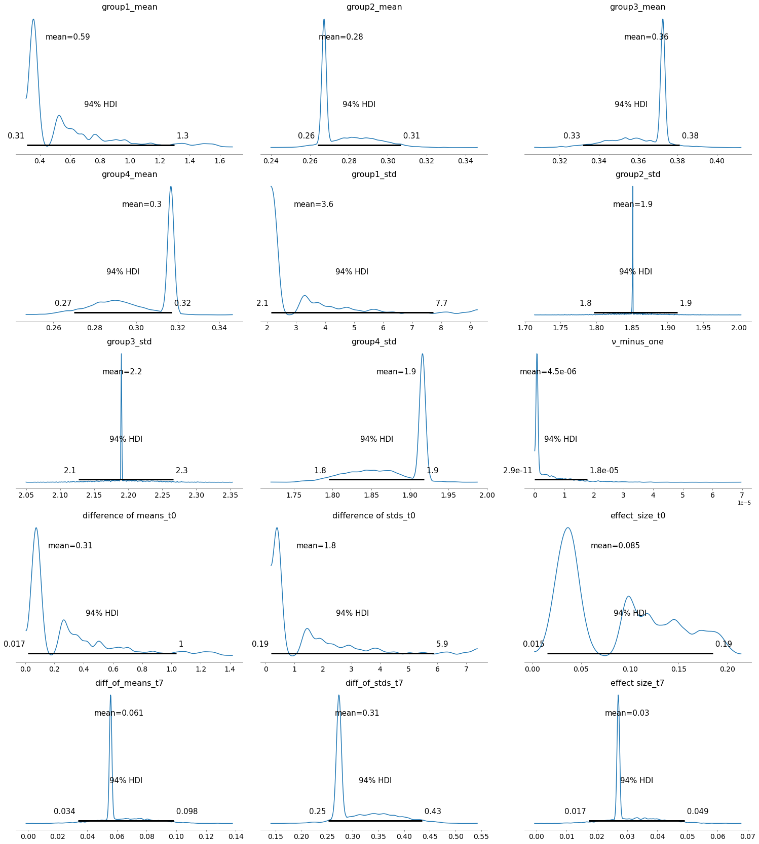   
**Figure 6.0** Comparative Analysis Control Group I Within Day It Carries

**Discussion**

In Figure 4.0, we can see differences of means and standard deviations between day 0 and day 7. We were able to have graph to predict for posteriors. Graphs are pretty clean. Metropolis method was not able to predict by itself so Nuts is also used. Metropolis and Nuts are two of the step methods. Step methods are ways to sample data.

In Figure 4.0, results were different than I was expecting. I planned that if means and sigma values are handled properly, I will be able to get posterior predictions. However, Day 0 and Day 1 differences information were not able to make me to predict or neither Day 2 and Day 7. Various step methods have been used, but results did not change that much. (Figure 5.0 )

For future investigation one more Bayesian model has been applied one for each Control and Test groups. It can be used to detect switch points, but other groups are also should be investigated. (Figure 7.0)metin, ekran görüntüsü, ekran, siyah içeren bir resim

Açıklama otomatik olarak oluşturuldu

**Figure 7.0** Posterior Analysis of Test Group I

There are also various implementations are tried but results were not promising. For more detailed results, project file should be checked. Pymc3 is lack of information about implementation about gene expressions datasets. It was so hard to find documentation which make sense when you apply gene expression data. I also want to indicate that Pymc3 models are so slow. So I also send Colab link which you can directly access results, too. [4] In last part of work, implementation of student test and Bayesian estimation is applied for Control Group I can be found.

**References**

1. O’Loughlin, A., Lynn, D., McGee, M., Doyle, S., McCabe, M., & Earley, B. (2012, June 18). Transcriptomic analysis of the stress response to weaning at housing in Bovine LEUKOCYTES using Rna-seq technology. Retrieved May 29, 2021, from https://bmcgenomics.biomedcentral.com/articles/10.1186/1471-2164-13-250
2. Geo accession viewer. (n.d.). Retrieved May 29, 2021, from https://www.ncbi.nlm.nih.gov/geo/query/acc.cgi?acc=GSE37447
3. Salvatier1, J., Wiecki​2, T., Fonnesbeck3, C., F, B., P, L., R, P., . . . JW, V. (2016, April 06). Probabilistic programming in python using pymc3. Retrieved May 29, 2021, from <https://peerj.com/articles/cs-55/>
4. <https://colab.research.google.com/drive/1DFq0bljB1dEHvE1Qh6BwrTzCdblOcnyK?usp=sharing>
5. PyMC3 Documentation - PyMC3 3.11.2 documentation. (n.d.). Retrieved July 07, 2021, from https://docs.pymc.io/
6. Bayes factors and MARGINAL LIKELIHOOD¶. (n.d.). Retrieved July 08, 2021, from https://pymc3.readthedocs.io/en/latest/notebooks/Bayes_factor.html#Bayesian-model-averaging